
Curley Park Rangers FC
Our Club’s Philosophy
Coaching Guidelines & Syllabus for u7s;
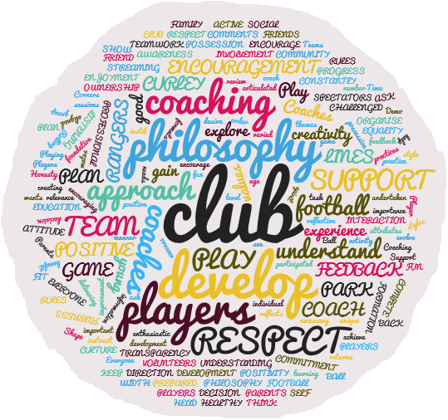

INTRODUCTION
This document sets out suggestions for a club syllabus for all coaches catering for player’s u7s to u8’s.
The purpose of this template programme is to give guidance and provide a suggested outline syllabus. The actual content for each group may require modification according to the age and ability of the players (and in line with Curley Park Rangers own ‘mission statement’ / ethos / philosophy).
The syllabus guidelines and the contents listed in each section are for guidance only. The content is suggested only to provide coaches with a framework in which to work or develop a club specific syllabus. The purpose is to provide a structure to the seasons coaching sessions, have a development plan for each team and more crucially, for individual players, have a checklist of targets. The idea is that the programme builds week on week, month by month, year on year, to a targeted outcome.
We start with what you might typically expect the characteristics traits to be of the players you are coaching…..
Typical Characteristics of u7 & u8 Players

- They tend to play well in pairs – unlike 6 year-olds, these children enjoy playing in pairs. Try to set up the pairs yourself to control the games and manage the personalities
- They are now able to take another’s perspective – they now have a sense of how other’s are feeling
- They are still unable to think abstractly – still do not have this capability, be patient.
- Their ‘heating and cooling’ system still less efficient than adults – still make sure to give frequent water breaks (every 8-10 minutes)
- Still much prefer playing to watching – keep everyone active during sessions and remember, no lines
- Limited attention span (on average 15-20 seconds for listening, up to 20 minutes when engaged in a task) – this may vary greatly on any given day depending on school, diet, etc. Try to get a gauge each day and do not fight crankiness.
- Have an understanding of time and sequence – they now understand “if I do this, then that happens”
- Many have incorporated a third or fourth speed into play – not all players, but many players now have incorporated a speed or two between stopped and as fast as possible.
- Extremely aware of adult reactions – be very aware of your verbal and nonverbal reactions, as they look for your reaction frequently.
- Seek out adult approval – be supportive when they ask about their performance or try to show you skills. They very much need reassurance and you need to help build their confidence to try new things at this age.
- Begin to become aware of peer perception – a social order is beginning to develop. Be sensitive to this.
- Wide range of abilities between children at this age – children all develop at varying paces. You may have an 8 year-old who seems more like a 10 year-old and one that seems more like a 6 year-old on the same team. Your challenge is to manage this range in your sessions in a way that challenges each player at a level that is reasonable for that player.
- Some will keep score – the competitive motors churn faster in some than others. Some parents will fuel the motors with their own. We do not need to stress winning and losing at this age. Results are not important at this age.
- Beginning to develop motor memories – by attempting fundamental technical skills they are training their bodies to remember certain movements.
- Less active imaginations than u6 players – still have active imaginations by adult standards, but some of the silliness that 6 year olds allowed will not be appreciated by this group. Still use their imaginations, just watch their reactions to games to read how far you can go with things.
The Programme Syllabus
Focus Blocks

This draft programme assumes 30 weeks of Training divided into ‘Blocks’ of 5 weeks. These are planned throughout the period from the start of Sept to the end of April, allowing for breaks during December & April. Practices relating to most of the suggested weeks can be found in ‘The Future Game’ Practice guide. They can be used directly or adapted for the numbers, age and ability of the group.
The clubs coaching and playing philosophy should also be keenly reflected in the execution of the sessions and on match days.

The Club Philosophy
Technical  A  CURLEY PARK RANGERS FC PLAYER | Psychological
Physical | Social

Our Philosophy has been updated by using the same approach adopted by the FA in creating England’s ‘DNA’. With the context of the ‘4 corner model’ (above) consideration has been given to the following:
- Who We Are
- How We Play:
- How We Coach
- How We Support
- Our Players

Specifically we have considered our approach to the following:

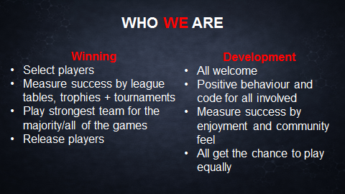

CURLEY PARK RANGERS MISSION STATEMENT

Curley Park Rangers mission is to be the focus of football for boys and girls from 5 years to 18 within the local community. We do so by providing a friendly & open atmosphere in which good sportsmanship combined with competitive play is encouraged.
Everyone is welcome to play & watch football in the spirit of the game. We strive to continuously improve our standards not only through adherence to the FA charter standard kitemark but also by continuously improving the quality of our coaches and playing facilities.

CURLEY PARK RANGERS – OUR MISSION MNEMONICS
C | Community | Community focussed, providing a focus of football for children in the local community.
U | Understand | Understand that everyone has different abilities & requirements to enjoy their football
R | Respect | Fully support the FA Respect programme, showing respect to everyone connected with & in contact with the club.
L | Life Skills | To provide a framework for children to develop life skills through their football
E | Educate | To provide learning opportunities for everyone associated with the club
Y | Yes | Yes to everyone who wants to play. We are an all inclusive club that will not turn any player away who agrees to play within the context of our philosophy.
P | Player | Player focussed. All of our efforts focussed to improve the experience of the players.
A | Achievement | Encourage every child to achieve success appropriate to their abilities.
R | Responsible | Take responsibility for ensuring that all of our football is played in a safe environment & that high standards of behaviour are maintained.
K | Kitemark | Fully support & adhere to the FA Charter Standard kitemark of quality

The Coaching Programme - Common Themes
There are some basic common themes running throughout the whole programme and all coaches are encouraged to follow these for the benefit of the players:
- …structure/plan your sessions, be creative and remember these are children not mini pro footballers.
- …set up arrival activities for players when they turn up to training
- …ensure all players have lots and lots and lots of touches of the ball in your session. So no queuing/waiting their turn.
- …focus on one or two points only (keep it simple, At this age it will mostly always be around keeping the ball
- …make sessions/match day experiences enjoyable
- …listen to your players, get their feedback, and show that you value their input. Engage them
- …encourage your players all the time. Be specific about what they are doing well at.
- …recognise & praise effort even when they are struggling. In fact more so when they are finding it hard. Create an environment that they want to keep trying.
- …be inclusive
- …avoid talking too much (target Ball Rolling Time >70% of time.
- …NO line drills, No waiting, no queues, it’s boring and players don’t learn from them.
- …reconcile expectations (players/parents/coaches).
- …reflect on your sessions (what went well , Even better if next time )

Imagine every player you have turn up is wearing two badges one says…’Please help me be the best player I can be’ and the other says ‘Please help me enjoy the session’
If you can help your players improve and they enjoy practice then you will be doing a great job as a coach.
Player Centred
Whilst this document sets out a syllabus of what is expected to be taught throughout the season, it is by no means prescriptive. The main themes of the blocks of work should be used as a guiding template for structuring practice. Coaches should use their knowledge and understanding of their players to adapt the programme to suit the needs of groups and individuals. Coaches do not have to cover all practice themes within the 5 week block if it is not appropriate to their players.
A Match Day Philosophy...Managing the Parents.
The Parents need to be aware of the rules and the coaching philosophy of the club.
1. Try to keep them informed of the coaching ‘blocks’ and what the targets are for each ‘block’. Explain if there is a policy of rotation what this means.
2. Encourage the parents / supporters to play a supporting role and never shout instructions to any of the players.
3. Ask the parents to represent the club as much as the players do by always respecting opponents, opposition coaches and officials
4. Explain we want to try to win the game, but not at the expense of the above points

Parents should be supportive. But not like this……
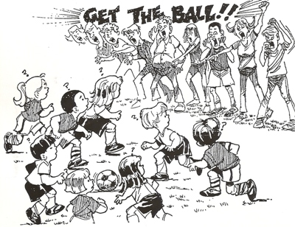
Food for Thought …..

ACTION COUPLING
(Courtesy of Ben Bartlett – FA)
This suggests that what the brain sees (perception) and what the body does (action) needs to be joined together (coupling). Techniques learned by the player in isolation usually do not transfer to the game because the player essentially has to re-learn the skill within the ever changing context of the match. As a result it begs the question whether the skill would be better taught within the game context in the first place.
A volley ball coach wishing to get his players to extend their arm more when spiking the ball, rather than explicitly describing the changes in technique that he wants to see, gradually increased the height of the net in training in increments so small that that the players did not notice.
Eventually the players noticed but that did not matter as the outcome had been achieved implicitly.

More Food for Thought…
A commonly held model of the learning process is that people start with a collection of rather rudimentary techniques and skills and by learning repeating hours and hours of monotonous mechanical practise miraculously hone and refine them into excellence.
While the hours are necessary they are not in themselves sufficient. Practice needs to be competitive, enjoyable, interesting, varied, and challenging rather than mindlessly repetitive. It also needs to be contextual and realistic. The more game like a practice is the more relevance it has to learning the game and how it works. Transfer issues disappear because there are no transfer issues.
Individuals will improve their performance and have a better chance of realising their potential not as an automatic outcome of more experience with an activity, but rather through focussed learning and committed adaptation to interesting and engaging experiences within match like activity.

(Courtesy of John Allpress – Sporting Futures)

The implications for each coach are that practices need to be designed that reflects the realities of the game and how it works and young players need to be active participants in their learning and treated as intelligent thinking beings not just performers there simply to be trained.

The next section provides a suggested syllabus for each age group from which adaption can be applied. They are divided into two year age groups and each one builds from the last.
Please help me enjoy the session
Please help me be the best player I can be

Imagine each player
wearing these badges when they
come to training and matches.
u7’s & u8’s Programme

This programme assumes 30 weeks of Training divided into ‘Blocks’ of 5 weeks. These are planned throughout the period from the start of Sept to the end of April, allowing for breaks during December & April. Practice ideas can be found in ‘The Future Game’ Practice guide. They can be used directly or adapted for the numbers, age and ability of the group.
Note, the u7’s & 8 children are more physically and maturationally developed then u6’s BUT we must remain patient and not force them to develop too quickly. The emphasis remains on getting them comfortable with a ball at their feet. Lots of opportunities for running with the ball and dribbling should be incorporated into sessions as well as chances for players to engage in more 1v1’s and 2v2’s. Passing will start to become more relevant as players begin to understand the benefits of working together.
We need to make sure that fun is a central theme in sessions. Player development will occur most appropriately and expeditiously if all players are enjoying themselves.
Below there are indicators what the objectives should be for this age group. Emphasis on Fun and no tactics.
All children should have a ball each and no line drills.

u7’s & u8’s 4 Corner Objectives for the Season:
TECHNICAL/TACTICAL  - Run with the ball keeping the ball close & under control  - Dribble past an opponent. Use both feet.  - Change direction with the ball using both feet  - Progress Turning with the ball using extended techniques & using both feet. i.e Inside & outside hook, Drag back turn, Stop turn,  - Shielding the ball under increased pressure.  - Progress Passing using both feet and using an increased variety of passing techniques inside/outside/laces/lofted/chipped.  - Develop cushion control control with first touch - introduction  - Progress Shooting at a target using both feet, inside of foot and laces.  - Tackling – Intro to pressurising the ball and tackling.  - Heading- Intro to be willing to head the Ball. Intro basic concept of headers.  - Juggling the ball (with one bounce). Use both feet.  - Basic understanding of competing in 1v1’s 2v2’s .  - Progression to 3v 3 & 4v4  - Goalie- Everyone takes turns.  - Use Hands, Feet, Body Positioning when in Goal. | PSYCHOLOGICAL  - Have Fun  - Have Fun  - Have Fun  - Lots of Encouragement to Try  - Decisions around dealing with 1v1, 2v2, 3v3 & 4v4  - Players get to play in all positions  - Creativity
PHYSICAL  - ABC’s  - FUNdamental Movements to development multi direction movement, Agility, Balance & Coordination of all body parts working together | SOCIAL  - The u7s/u8’s can start to work in pairs  - Have Fun  - Have Fun
u7 & u8’s Season Plan
BLOCK NO. | Practise Theme | Linked To… | Suggested Guide to Weeks contents…
1  Weeks 1-5 | General | FUNdamental movements,  Ball Mastery,  Running, Dribbling & Turning with the ball. | Wk 1. – FUNdamental Movements- TAG Games/ Handball games/ Variety of Ball manipulations / SSG  Wk 2. - FUNdamental Movements- TAG Games/ Running with the ball. Variety of Ball manipulations/ SSG  Wk 3. - FUNdamental Movements- TAG Games / Dribbling the ball. Variety of Ball manipulations/ SSG  Wk 4. – FUNdamental Movements- TAG Games / Turning with the ball. Ball manipulation/ SSG
 |  | Review progress | Reflection Week – Consider areas to revisit / More SSG’s.
2  Weeks 6-10 | General | FUNdamental movements,  Ball Mastery,  Passing  Dribbling  1v1’s 2v2’2 | Wk 1. – FUNdamental Movements- ABC’s/ Handball games/ Variety of Ball manipulations/ Passing & Receiving / SSG  Wk 2. - FUNdamental Movements- ABC’s / Variety of Ball manipulations/ Running with the ball, passing & receiving/ SSG.  Wk 3. - FUNdamental Movements- ABC’s / Dribbling /1v1’s & Passing  Wk 4. – FUNdamental Movements- ABCs/ Running/Dribbling/and passing with the ball 1v1’s , 2v1’s & 2v2’s
 |  | Review progress | Reflection Week – Consider areas to revisit / More SSG’s.
3  Weeks 11-15 | General | FUNdamental movements,  Ball Mastery,  Turning  Shielding | Wk 1. – FUNdamental Movements- ABC game/ Variety of Ball manipulations/ Turning (increased variety)/ SSG  Wk 2. - FUNdamental Movements- ABC game/ Variety of Ball manipulations/ 1v1’s/2v1’s/2v2’s - Shielding  Wk 3. - FUNdamental Movements- ABC game/ Passing & Receiving  Wk 4. – FUNdamental Movements- ABC Game / Running/Dribbling/Turning/Passing in SSG’s.
 |  | Review progress | Reflection Week – Consider areas to revisit / More SSG’s.
4  Weeks 16-20 | General | FUNdamental movements,  Ball Mastery,  Throw ins  Headers | Wk 1. – FUNdamental Movements- ABC game/ Variety of Ball manipulations/ Passing & Receiving/Throws & Heading/SSG  Wk 2. - FUNdamental Movements- ABC game/ Variety of Ball manipulations/Running with the ball, Passing & First Touch control/ SSG  Wk 3. - FUNdamental Movements- ABC game / Turning and Passing/SSG  Wk 4. – FUNdamental Movements- ABC game / Throws & Headers/ 1v1 dribbling SSG
 |  | Review Progress | Reflection Week – Consider areas to revisit / More SSG’s.
5  Weeks 21-25 | General | FUNdamental movements,  Ball Mastery,  Shooting | Wk 1. – FUNdamental Movements- ABC game / Handball games/ Variety of Ball manipulations/ Shooting inside of foot & laces.  Wk 2. - FUNdamental Movements- ABC game/ Variety of Ball manipulations/ Running with the ball and Shooting  Wk 3. - FUNdamental Movements- ABC Game / Passing, Receiving & Shooting /SSG  Wk 4. – FUNdamental Movements- ABC game / Shielding , turning to shoot./ SSG
 |  | Review progress | Reflection Week – Consider areas to revisit / More SSG’s.
6  Weeks  26-30 | General | FUNdamental movements.  Selected Areas | Wk 1. – FUNdamental Movements- ABC game / Variety of Ball manipulations/ Revisit / repeat selected session as required.  Wk 2. - FUNdamental Movements- ABC game/ Variety of Ball manipulations/ Revisit / repeat selected session as required.  Wk 3. - FUNdamental Movements- ABC game / Variety of ball manipulations/ Revisit / repeat selected session as required.  Wk 4. – FUNdamental Movements- ABC game / Variety of ball manipulations/ Revisit / repeat selected session as required.
 |  | Review progress | Reflection Week – Consider areas to revisit / More SSG’s.

